
Viewed by:
Philippe POHER
Tel.: +33 (0)2 99 27 92 92
E-mail: philippe.poher@iwedia.com

Written by:
Fabien DUTERTRE
Tel.: +33 (0)2 99 27 92 92
E-mail:fabien.dutertre@iwedia.com
IWEDIA

TDAL_DMD Technical Specifications

V3.1

Approved by:
Thierry GARNIER
Tel.: +33 (0)2 99 27 92 92
E-mail: thierry.garnier@iwedia.com

SUMMARY
1 Reference documents 4
2 Documentation History 5
3 Introduction 8
4 Module Overview and Architecture 9
4.1 Definitions, Acronyms and Abbreviations 9
4.2 General Description 9
4.2.1 Tuning Behavior 10
4.2.2 Scanning Behavior 10
4.2.3 Management Behavior 10
4.2.4 TS reliability 10
4.2.5 Front-End Satellite: DiSEqC 11
4.2.6 Interactions with TDAL_ANA_AUD module 13
4.2.7 Interactions with TDAL_ANA_VID module 13
4.3 Architecture 14
4.4 TDAL_DMD API Description 15
4.4.1 Generic Interface 15
5 TDAL_DMD API Specification 16
5.1 Type Specifications 16
5.1.1 Generic 16
5.1.2 Demod Instances Interface 16
5.2 TDAL_DMD API Usage 17
5.2.1 Initialisation and Open Front End Instance 17
5.2.2 Close Front End Instance and Terminate 18
5.2.3 Tune on a specific frequency 19
5.2.4 Scan on a band of frequencies 20
5.2.5 Signal Lost 21
5.3 TDAL_DMD Macro/Define/Enum/Typedef/Structure Definitions 22
5.3.1 Define Definitions 22
5.3.2 Enum Definitions 22
5.3.2.1 Common types 22
5.3.2.2 Satellite types 25
5.3.2.3 Cable types 27
5.3.2.4 Terrestrial types 28
5.3.3 TypeDef Definition 30
5.3.3.1 tTDAL_DMD_ConfigData 30
5.3.3.2 tTDAL_DMD_SpecificTunData 30
5.3.3.3 tTDAL_DMD_CabTunData 30
5.3.3.4 tTDAL_DMD_ScanData 30
5.3.3.5 tTDAL_DMD_NotifyProgress 31
5.3.3.6 tTDAL_DMD_NotifyStatusFct 31
5.3.3.7 tTDAL_DMD_NotifyProgressFct 31
5.3.4 Structure Definitions 32
5.3.4.1 Common Structures 32
5.3.4.2 Satellite Structures 35
5.3.4.3 Cable Structures 42
5.3.4.4 Terrestrial Structures 44
5.4 TDAL_DMD API Functions 48
5.4.1 Generic Interface API 48
5.4.1.1 TDAL_DMD_Init(-) 48
5.4.1.2 TDAL_DMD_Terminate(-) 48
5.4.1.3 TDAL_DMD_OpenFEInstance(-) 49
5.4.1.4 TDAL_DMD_CloseFEInstance(-) 50
5.4.1.5 TDAL_DMD_GetCapability(-) 51
5.4.1.6 TDAL_DMD_GetFECapability(-) 52
5.4.1.7 TDAL_DMD_Config(-) 53
5.4.1.8 TDAL_DMD_APIRevisionGet(-) 54
5.4.1.9 TDAL_DMD_PlatformRevisionGet(-) 55
5.4.1.10 TDAL_DMD_Tune(-) 56
5.4.1.11 TDAL_DMD_StartScan(-) 57
5.4.1.12 TDAL_DMD_ContScan(-) 58
5.4.1.13 TDAL_DMD_StopScan(-) 59
5.4.1.14 TDAL_DMD_Unlock(-) 60
5.4.1.15 TDAL_DMD_GetInfo(-) 61
5.4.1.16 TDAL_DMD_GetTSReliability(-) 62
5.4.1.17 TDAL_DMD_HandleGet(-) 64
6 TDAL_DMD_EXTERNAL_DEPENDENCIES 65
6.1 tTDAL_DMD_NotifyStatusFct 65
6.2 tTDAL_DMD_NotifyProgressFct 66

Reference documents
The following documents were used to write this specification:

Document | Version | Title

Documentation History

History
Vers. | Date | Nature
1.0 | 13/02/2004 | XARA : creation
1.1 | 19/02/2004 | - tTDAL_DMD_DiSEqCFrame suppressed of tTDAL_DMD_SatTunData structure.  - All specific tTDAL_DMD_ConfigData structures modified.  - tTDAL_DMD_SatCfgData modified for DiSeqC and Tone burst commands.  - Field Name added in TDAL_DMD_Open function. (permits to select the constructor).  uiFeID replaced by ucFeID.
1.2 | 13/04/2004 | - TDAL_DMD_Open replace by TDAL_DMD_Init.  - TDAL_DMD_Close replace by TDAL_DMD_Terminate.  - ucSysId parameter added in the TDAL_DMD_Init, tTDAL_DMD_NotifyStatusFct and tTDAL_DMD_NotifyProgressFct functions.  - tTDAL_DMD_LNB_Data structure suppressed.  - tTDAL_DMD_SatTunData modified: tTDAL_DMD_LNB_Data field replace with tTDAL_DMD_Polarization.  - tTDAL_DMD_TunData modified: TunFrequency added.  - tTDAL_DMD_NotifyStatus modified: eTDAL_DMD_FOUND added and eTDAL_DMD_SIGNAL_ON suppressed.  - tTDAL_DMD_Info modified: TunData field replaces all tuning info.  - TDAL_DMD_Tune function prototype modified: Frequency suppressed.  - eTDAL_DMD_SCAN_FAILED enum suppressed.  - In tTDAL_DMD_BandType enum, only eTDAL_DMD_BANDTYPE_KU and eTDAL_DMD_BANDTYPE_C.  - eTDAL_DMD_LNB_POWER_DEFAULT and eTDAL_DMD_POLAR _POWER_DEFAULT suppressed.  - eTDAL_DMD_CFG_SAT_OL_BAND added in tTDAL_DMD_SatConfigType structure.  - OlBand field added in tTDAL_DMD_SatCfgData structure.  - eTDAL_DMD_ODU_TONE_NONE added in tTDAL_DMD_ODU_ToneState enum.  - eTDAL_DMD_ODU_POWER_NONE added in tTDAL_DMD_ODU_Power enum.  - tTDAL_DMD_LNB_Polarization enum modified for compilation.
1.3 | 26/04/04 | Editorial review
1.4 | 10/05/04 | - eTDAL_DMD_UNLOCKED suppressed in tTDAL_DMD_NotifyStatus and eTDAL_DMD_LOCK_FAILED added.  - tTDAL_DMD_BandType modified: KU/C inverted.  - t TDAL_DMD_ODU_DiSEqC added and replace tTDAL_DMD_ODU_DiSEqCFrame in tTDAL_DMD_SatCfgData structure.
1.5 | 24/08/04 | - TunFrequency replaces TunFreqChan in tTDAL_DMD_TunData structure
1.6 | 09/11/04 | - tTDAL_DMD_CFG_StandByMode added in tTDAL_DMD_SatCfgData structure and eTDAL_DMD_CFG_STAND_BY_MODE enum added in tTDAL_DMD_SatConfigType. Used in stand Bye mode for low power.  - tTDAL_DMD_Pio ePio field added in TDAL_DMD_Init to set the pin IN used for the Front-End-Lock report.
1.7 | 06/01/05 | - LowLNBFreq and HighLNBFreq in tTDAL_DMD_SatOlBand structure : unit in KHz replace with MHz  - SwitchFreq in tTDAL_DMD_SatInitData: unit in KHz replace with Hz.  - Field SysId suppressed in TDAL_DMD_Init function  - eTDAL_DMD_NOT_LOCKED return value suppressed for TDAL_DMD_GetInfo.
1.8 | 20/04/07 | - Add Antenna Power Status
2.0 | 10/01/08 | - Editorial review
2.1 | 10/04/08 | - Add TS reliability feature  - FOUND Event is used during the scanning process
2.2 | 23/05/08 | - Update for tTDAL_DMD_CFG_StandByMode  - Update for tTDAL_DMD_TerSourceState
2.3 | 08/10/08 | - Add the terrestrial analog mode description and TDAL_ANA_VID, TDAL_ANA_AUD dependency.  - Add an anlog fine tune offset in TER tune data.  - Do some layout updates
3.0 | 17/10/08 | - Modify Init sequence  - Add capabilities get function
3.1 | 06/04/09 | - Add explanation for TDAL_DMD_Tune()  - Add explanation for TDAL_DMD_GetInfo()

Introduction
The purpose of this document is to specify the interface and to describe the internal design of the Thin Driver Adaptation Layer Demod [TDAL_DMD]. The aim of this module is to allow to a client module to set and get the front-end parameter, start a tuning or scanning, handle the front-end states and notify the client. It relies on the native driver API.

Module Overview and Architecture

Definitions, Acronyms and Abbreviations
API | Application Programmer’s Interface
STB | Set Top BOX
DVB | Digital Video Broadcast
TS | Transport Stream
LNB | Low Noise Block
ODU | Out Door Unit
DMD | Demodulator
AGC | Automatic Gain Control
BER | Bit Error Rate
DiSEqC | Digital Satellite Equipment Control
IF | Intermediate Frequency
CVBS | Composite Video, Blanking, Synchronization: (Video format where luminance, chrominance, blanking, and synchronization are integrated in one signal)
SIF | Sound Intermediate Frequency
Hybrid | Defines a demodulator whicj is able to process digital and analog modulation.

General Description
The main job of the TDAL_DMD is to control the demodulator and the tuner of the set top box or and IDTV platform. With some hardwares, there are two tuners, the TDAL_DMD module must be able to manage the two tuners in the same times.
With a terrestrial signal, two operation modes can be managed by the IF demodulator part of the demodulation chain:
- Analog mode,
- Digital mode.
In analog mode, the demodulator processes analog vision demodulation to get a CVBS baseband signal and processes analog sound demodulation to get a SIF signal.
In digital mode, the demodulator processes digital channel demodulation to get a digital transport stream.
Some general functionalities are proposed to the client.
The tuning on a specified carrier and get the signal quality parameters then detected.
The scanning among the frequency domain until a carrier is detected, in this case the associated quality information are given.
The management about demodulation events, as losing signal or signal being disturbed.

Tuning Behavior
A Tune with good parameters should lock and the client of the TDAL_DMD module must received only one notification LOCKED.
A client could call two tunes without waiting the notification of the first tune command. The two tunes have two differents set of parameters which should lock. The client should received the notification indicates locked status and the GetInfo returns the second set of parameter values. The second tune cancels the first tune.

Scanning Behavior
When a scan is started, the module returns the notification END_OF_RANGE if no frequencies are found or if there is no signal. The notification FOUND is sent when a frequency is found. In this case, the scanning is stopped. The client may continue the scanning.
Two scans on the same range of frequencies should give the same frequencies informations and the same number of frequencies.

Management Behavior
The module TDAL_DMD has to manage the behavior of the signal.
If the signal is lost (antenna cable unplug), the notification SIGNAL_LOST must be send to the client but the module tries to relock. If it succeeds, the notification LOCK is sent.
When the signal is lost, the client could try to tune on other correct frequency. The module must try to relock on the new frequency. When, the signal come back, the notification LOCK must be send and the GetInfo returns the parameters of the new frequency.

TS reliability
In order to manage correctly TS choice during an installation, the client needs to know to reliability of TS signal.
Three values could give the reliability:
Signal Quality: C/N
Signal Level: AGC
Bit Error Rate commonly called BER.
Those three values are returned through GetInfo Function call.
But the BER wich the unit is not specified can not be directly use by the client because of platform diversity.
The function GetTSReliability is intended to return the real reliability regarding the platform specifities.
This function is always preceeded by a GetInfo Call. Input parameters for this function are the current TS information structure, its previous signal quality, level and BER.
This function must compute/convert the original BER to three parameter wich could be displayed on screen (quo,rem*10e-exp).
This function must also give a reliability factor from 0-100.
This function implementation is very specific to the current platform, it could either requests to low level driver updated information or only use the input parameter in order to compute the reliability factor.
The implementation must take care to provide the good value, if it is not the case, the client could choice a TS with high quality but high error rate instead of TS with medium quality but with no Error.

Front-End Satellite: DiSEqC
DiSEqC is a special communication protocol for use between a satellite receiver and a device such as a multi-dish switch or a small dish antenna rotor. It relies only on the coaxial cable to transmit both signals and power with the LNB.
DiSEqC is commonly used to control multiswitches and claims to be more flexible than 13/18 volt and 22 kHz tone or ToneBurst techniques.
A number of variations of DiSEqC exist:
- DiSEqC 1.0, which allows switching between up to 4 satellite sources
- DiSEqC 1.1, which allows switching between up to 16 sources
- DiSEqC 1.2, which allows switching between up to 16 sources, and control of a simple horizontal-panning satellite motor
- DiSEqC 2.0, which adds bi-directional communications to DiSEqC 1.2
They are all back compatible - a DiSEqC 2.0 receiver can control a 1.0 switch but a 1.0 receiver cannot control motorised features.
The vast majority of European satellite receivers support at least DiSEqC 1.2. The module TDAL_DMD supports only the DiSEqC 1.0 and 1.2.

Interactions with TDAL_ANA_AUD module
TDAL_ANA_AUD needs an access to the demodulator of TDAL_DMD to indicate in which audio decoder, the analog audio stream chosen result must be sent.
For that purpose and to have a complete independence between the TDAL_ANA_AUD, TDAL_DMD and other TDAL APIs, the notion of input handle is used. The input handle is an unique opaque value that is used as accessor to a specific analog audio stream. This handle is used transversely between the different TDAL modules in order to authorize a TDAL module to access the low level driver that manages the decoders.
See [TDAL_ANA_AUD] for more details.

Interactions with TDAL_ANA_VID module
TDAL_ANA_VID needs an access to the demodulator of TDAL_DMD to indicate in which video decoder, the analog video stream chosen result must be sent.
For that purpose and to have a complete independence between the TDAL_ANA_VID, TDAL_DMD and other TDAL APIs, the notion of input handle is used. The input handle is an unique opaque value that is used as accessor to a specific analog audio stream. This handle is used transversely between the different TDAL modules in order to authorize a TDAL module to access the low level driver that manages the decoders.
See [TDAL_ANA_AUD] for more details.

Architecture
The figure below shows the relation between the client module and the low level drivers:
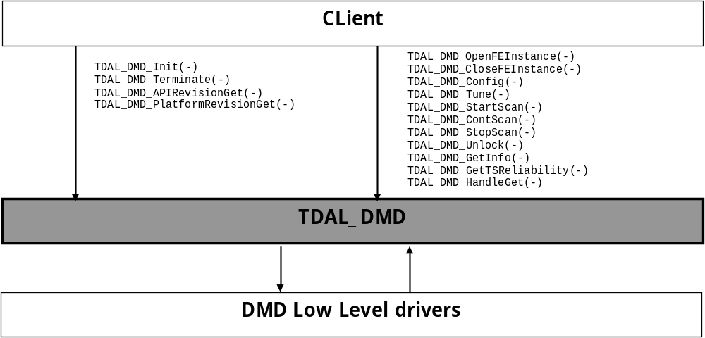

TDAL_DMD API Description

Generic Interface
The generic interface allows clients to control the TDAL_DMD module.
This interface is used with the following functions:
- TDAL_DMD_Init(-) in order to initialize the TDAL_DMD module.
- TDAL_DMD_Term(-) in order to terminate the TDAL_DMD module.
- TDAL_DMD_APIRevisonGet(-) in order to retrieves the API revision.
- TDAL_DMD_PlatformRevisonGet(-) in order to retrieves the platform implementation revision.
- TDAL_DMD_GetCapability(-) in order to get number of front end instances available on the platform.
- TDAL_DMD_GetFECapability(-) in order to get capabilities of a front end instance.
- TDAL_DMD_OpenFEInstance(-) in order to open a Front End instance.
- TDAL_DMD_CloseFEInstance(-) in order to close a Front End instance.
- TDAL_DMD_Tune(-) in order to perform a tuning on a specific frequency.
- TDAL_DMD_StartScan(-) in order to start a scanning on a band of frequencies.
- TDAL_DMD_ContScan(-) in order to continue the current scanning.
- TDAL_DMD_StopScan(-) in order to stop the current scanning.
- TDAL_DMD_Config(-) in order to set the configuration of the tuner, to manage the standby to reduce power consumption.
- TDAL_DMD_Unlock(-) in order to unlock the Front-End from the current frequency.
- TDAL_DMD_GetInfo(-) in order to get the info of the frequency locked.
- TDAL_DMD_GetReliability(-) in order to get a TS quality from the low level driver point of view.
- TDAL_DMD_HandleGet(-) in order to to get an opaque unique handle on an analog demodulated stream.

TDAL_DMD API Specification

Type Specifications

Generic
tTDAL_DMD_Error defines error values detected by tdal_dmd functions.

Demod Instances Interface
tTDAL_DMD_Type is used to define demod type.
tTDAL_DMD_NotifyStatus defines the message status returns by the callback.

TDAL_DMD API Usage

Initialisation and Open Front End Instance
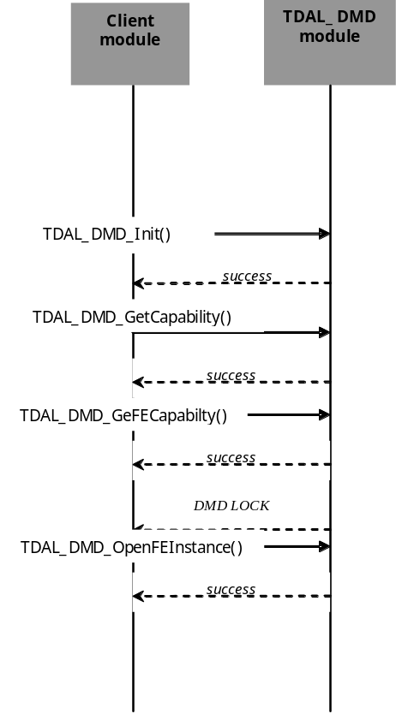

Close Front End Instance and Terminate
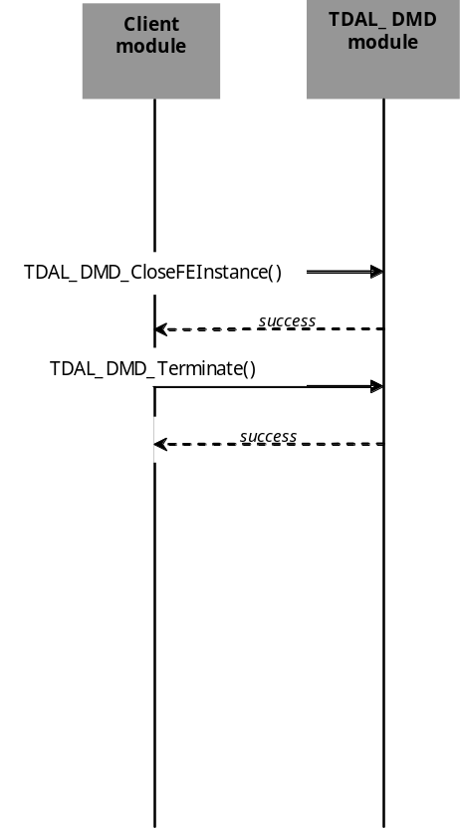

Tune on a specific frequency
The initialisation of TDAL_DMD API is made. The configuration of the driver is then done and the call to the specific frequency.

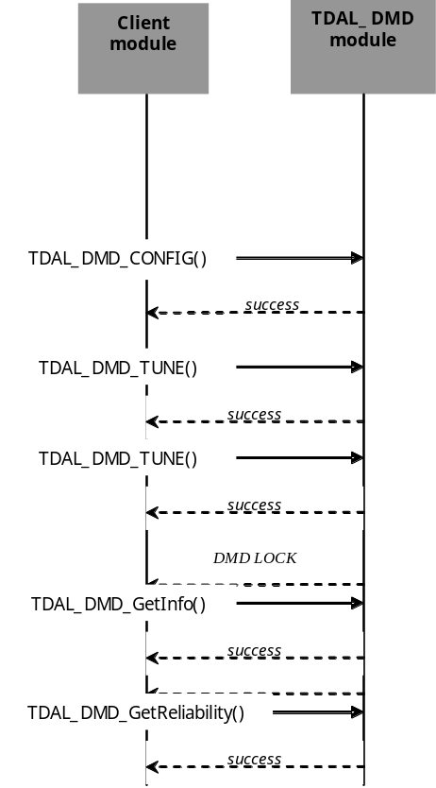

Scan on a band of frequencies
The initialisation of TDAL_DMD API is made. The configuration of the driver is then done and the call to the StartScan function. When the Demod is locked, the driver has to call the ContScan function. If the endFreq has been reached without a lock, the notification eTDAL_DMD_END_OF_RANGE is sent.

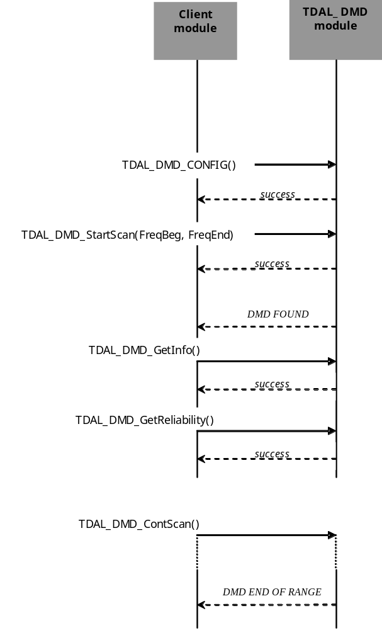

Signal Lost
The initialisation of TDAL_DMD API is made. The configuration of the driver is then done and the call to the specific frequency. Unplugged and plug the signal.

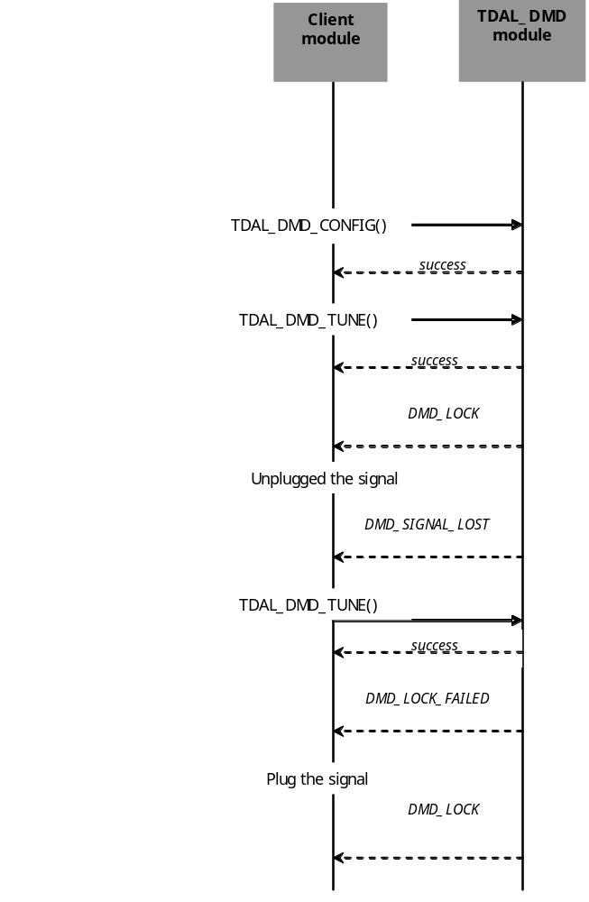

TDAL_DMD Macro/Define/Enum/Typedef/Structure Definitions

Define Definitions
None

Enum Definitions

Common types

tTDAL_DMD_Error
An enumeration of the different possible error returned by TDAL_DMD.
typedef enum
{
eTDAL_DMD_NO_ERROR = 0, /* No Error returned */
eTDAL_DMD_BAD_DEMODULATOR, /Wrong ID demod */
eTDAL_DMD_BAD_PARAMETER, /* Bad parameter given to the function */
eTDAL_DMD_DEVICE_BUSY, /*Problem occurs in low level driver*/
eTDAL_DMD_NOT_SCANNING,
eTDAL_DMD_NOT_LOCKED
} tTDAL_DMD_Error;

tTDAL_DMD_FE
An enumeration of the different possible Front End Instances Identifier.
typedef enum
{
eTDAL_DMD_FE_0 = 0x00000000,
eTDAL_DMD_FE_1 = 0x00000001,
eTDAL_DMD_FE_2 = 0x00000002,
eTDAL_DMD_FE_3 = 0x00000003,
eTDAL_DMD_NB_MAX_FE_ID
} tTDAL_DMD_FE;

tTDAL_DMD_NotifyStatus
An enumeration of the different messages returned by callback to the application.
typedef enum
{
eTDAL_DMD_LOCKED = 0,
eTDAL_DMD_LOCK_FAILED,
eTDAL_DMD_FOUND,
eTDAL_DMD_END_OF_RANGE,
eTDAL_DMD_SIGNAL_LOST,
} tTDAL_DMD_NotifyStatus;

tTDAL_DMD_Type
An enumeration of the different tuners (Satellite, Cable and terrestrial).
typedef enum
{
eTDAL_DMD_TYPE_QPSK = 0,
eTDAL_DMD_TYPE_QAM,
eTDAL_DMD_TYPE_OFDM
} tTDAL_DMD_Type;

tTDAL_DMD_SourceSupport
An enumeration of the source support capability (DIGITAL only, Analog only, Hybrid (digital and analog)
typedef enum
{
eTDAL_DMD_DIGITAL,
eTDAL_DMD_ANALOG,
eTDAL_DMD_HYBRID
}tTDAL_DMD_SourceSupport;

tTDAL_DMD_Modulation
An enumeration of all the modulations supported by the TDAL_DMD driver.
typedef enum
{
eTDAL_DMD_MOD_BPSK = 0,
eTDAL_DMD_MOD_QPSK,
eTDAL_DMD_MOD_QAM4 = eTDAL_DMD_MOD_QPSK,
eTDAL_DMD_MOD_8PSK,
eTDAL_DMD_MOD_QAM16,
eTDAL_DMD_MOD_QAM32,
eTDAL_DMD_MOD_QAM64,
eTDAL_DMD_MOD_QAM128,
eTDAL_DMD_MOD_QAM256,
eTDAL_DMD_MOD_AUTO,
eTDAL_DMD_MOD_MAX
} tTDAL_DMD_ Modulation;

tTDAL_DMD_Spectrum
An enumeration of all the spectres supported by the TDAL_DMD driver.
2.1.1.8 - tTDAL_DMD_Spectrum
typedef enum
{
eTDAL_DMD_SPECTRUM_AUTO = 0,
eTDAL_DMD_SPECTRUM_NORMAL,
eTDAL_DMD_SPECTRUM_INVERTED,
eTDAL_DMD_SPECTRUM_MAX
} tTDAL_DMD_Spectrum;

tTDAL_DMD_Status
An enumeration of all the states supported by the TDAL_DMD driver.
typedef enum
{
eTDAL_DMD_STATUS_LOCKED = 0,
eTDAL_DMD_STATUS_UNLOCKED,
eTDAL_DMD_STATUS_SCANNING,
eTDAL_DMD_STATUS_SIGNAL_LOST
} tTDAL_DMD_Status;

tTDAL_DMD_Convolution
An enumeration of all the convolutions supported by the TDAL_DMD driver.
2.1.2.1 - tTDAL_DMD_Convolution
typedef enum
{
eTDAL_DMD_FEC_NONE,
eTDAL_DMD_FEC_1_2,
eTDAL_DMD_FEC_2_3,
eTDAL_DMD_FEC_3_4,
eTDAL_DMD_FEC_4_5, (*)
eTDAL_DMD_FEC_5_6,
eTDAL_DMD_FEC_6_7,
eTDAL_DMD_FEC_7_8,
eTDAL_DMD_FEC_8_9, (*)
eTDAL_DMD_FEC_AUTO,
eTDAL_DMD_FEC_MAX
} tTDAL_DMD_Convolution;
(*): 4/5, 8/9 not used normally.

tTDAL_DMD_CFG_StandByMode
An enumeration of the standby action requires from the tuner to reduce the power consumption of the final product.
typedef enum
{
eTDAL_DMD_STANDBYMODE_OFF,
eTDAL_DMD_STANDBYMODE_ON
} tTDAL_DMD_CFG_StandByMode;.

Satellite types

tTDAL_DMD_LNB_Polarization
An enumeration of all the polarizations supported by the TDAL_DMD driver.
typedef enum
{
eTDAL_DMD_POLAR_HORIZONTAL,
eTDAL_DMD_POLAR_VERTICAL,
eTDAL_DMD_POLAR_CIRCULAR_LEFT, // not implemented by application
eTDAL_DMD_POLAR_CIRCULAR_RIGHT, // not implemented by application
eTDAL_DMD_POLAR_ALL // not implemented by application
} tTDAL_DMD_LNB_Polarization;

tTDAL_DMD_SatConfigType
An enumeration of the different satellite initialisations.
2.1.2.4 - tTDAL_DMD_SatConfigType
typedef enum
{
eTDAL_DMD_CFG_SAT_INIT,
eTDAL_DMD_CFG_SAT_OL_BAND,
eTDAL_DMD_CFG_STAND_BY_MODE,
eTDAL_DMD_CFG_ SAT_ODU_TONE_STATE,
eTDAL_DMD_CFG_ SAT_ODU_POWER,
eTDAL_DMD_CFG_ SAT_ODU_TONE_BURST,
eTDAL_DMD_CFG_ SAT_ODU_DISEQC,
eTDAL_DMD_CFG_ SAT_OTHER
} tTDAL_DMD_SatConfigType;

tTDAL_DMD_BandType
An enumeration of all the bands supported by the TDAL_DMD driver.
typedef enum
{
eTDAL_DMD_BANDTYPE_KU = 0,
eTDAL_DMD_BANDTYPE_C
} tTDAL_DMD_BandType;

tTDAL_DMD_LNB_Power
An enumeration of all the powers supported by the TDAL_DMD driver.
typedef enum
{
eTDAL_DMD_LNB_POWER_13V,
eTDAL_DMD_LNB_POWER_18V
} tTDAL_DMD_LNB_Power;

tTDAL_DMD_CFG_StandByMode
An enumeration to give the different configurations with the lnb power.
typedef enum
{
eTDAL_DMD_STANDBYMODE_OFF, /* LNB supply ON and Low power demodulator activated.*/
eTDAL_DMD_STANDBYMODE_ON /*LNB supply OFF and Low power demodulator non activated.*/
} tTDAL_DMD_CFG_StandByMode

tTDAL_DMD_ODU_ToneBurst
An enumeration of all the possibilities of toneBurst.
typedef enum
{
eTDAL_SatelliteA,
eTDAL_SatelliteB
}tTDAL_DMD_ODU_ToneBurst;

tTDAL_DMD_ODU_ToneState
An enumeration of all the possibilities of tone state.
typedef enum
{
eTDAL_DMD_ODU_TONE_NONE,
eTDAL_DMD_ODU_TONE_OFF,
eTDAL_DMD_ODU_TONE_ON
} tTDAL_DMD_ODU_ToneState;

tTDAL_DMD_ODU_Power
An enumeration of all the possibilities of power supply.
typedef enum
{
eTDAL_DMD_ODU_POWER_NONE,
eTDAL_DMD_ODU_POWER_13V,
eTDAL_DMD_ODU_POWER_18V
} tTDAL_DMD_ODU_Power;

Cable types

tTDAL_DMD_CabConfigType
An enumeration of the different cable initialisations.
typedef enum
{
eTDAL_DMD_CFG_CAB_INIT,
eTDAL_DMD_CFG_ CAB_OTHER
} tTDAL_DMD_CabConfigType;

Terrestrial types

tTDAL_DMD_TerMode
An enumeration of all the modes supported by the TDAL_DMD driver.
typedef enum
{
eTDAL_DMD_MODE_2K,
eTDAL_DMD_MODE_8K,
eTDAL_DMD_MODE_AUTO,
eTDAL_DMD_MODE_MAX
}tTDAL_DMD_TerMode;

tTDAL_DMD_TerGuard
An enumeration of all the guards supported by the TDAL_DMD driver.
typedef enum
{
eTDAL_DMD_GUARD_1_32,
eTDAL_DMD_GUARD_1_16,
eTDAL_DMD_GUARD_1_8,
eTDAL_DMD_GUARD_1_4,
eTDAL_DMD_GUARD_AUTO,
eTDAL_DMD_GUARD_MAX
}tTDAL_DMD_TerGuard;

tTDAL_DMD_TerHierarchy
An enumeration of all the hierarchies supported by the TDAL_DMD driver.
typedef enum
{
eTDAL_DMD_HIER_NONE,
eTDAL_DMD_HIER_1,
eTDAL_DMD_HIER_2,
eTDAL_DMD_HIER_4,
eTDAL_DMD_HIER_AUTO,
eTDAL_DMD_HIER_MAX
}tTDAL_DMD_TerHierarchy;

tTDAL_DMD_TerPrioStream
An enumeration of all the priorities supported by the TDAL_DMD driver.
typedef enum
{
eTDAL_DMD_PRIORITY_STREAM_HIGH,
eTDAL_DMD_PRIORITY_STREAM_LOW,
eTDAL_DMD_PRIORITY_STREAM_MAX
}tTDAL_DMD_TerPrioStream;

tTDAL_DMD_TerFreqOff
An enumeration of all the frequence offsets supported by the TDAL_DMD driver.
typedef enum
{
eTDAL_DMD_OFFSET_NONE,
eTDAL_DMD_OFFSET_1_6_MORE, /* + 1/6 Mhz */
eTDAL_DMD_OFFSET_1_6_MINUS, /* - 1/6 Mhz */
eTDAL_DMD_OFFSET_2_6_MORE, /* + 2/6 Mhz */
eTDAL_DMD_OFFSET_2_6_MINUS, /* - 2/6 Mhz */
eTDAL_DMD_OFFSET_3_6_MORE, /* + 3/6 Mhz */
eTDAL_DMD_OFFSET_3_6_MINUS, /* - 3/6 Mhz */
eTDAL_DMD_OFFSET_AUTO,
eTDAL_DMD_OFFSET_MAX,
}tTDAL_DMD_TerFreqOff;

tTDAL_DMD_TerConfigType
An enumeration of the different terrestrial initialisations.
typedef enum
{
eTDAL_DMD_CFG_TER_INIT,
eTDAL_DMD_CFG_ TER_OTHER,
eTDAL_DMD_CFG_TER_ANTENNA_POWER_STATUS
tTDAL_DMD_TerConfigType

tTDAL_DMD_TerSourceState
An enumeration of the diffrente source state of the tuner.
typedef enum
{
eTDAL_DMD_CFG_SOURCE_IS_ATV, /* analog mode */
eTDAL_DMD_CFG_SOURCE_IS_DTV /* digital mode */
}tTDAL_DMD_TerSourceState;

TypeDef Definition

tTDAL_DMD_ConfigData
Description:
An union to choose the right config(Sat,Ter,Cab).
Definition:
typedef union
{
tTDAL_DMD_SatCfgData Sat;
tTDAL_DMD_CabCfgData Cab;
tTDAL_DMD_TerCfgData Ter;
} tTDAL_DMD_ConfigData;

tTDAL_DMD_SpecificTunData
Description:
An union to choose the right specific parameters. It depend on the type of the demodulator(Sat,Ter,Cab).
Definition:
typedef union
{
tTDAL_DMD_SatTunData Sat;
tTDAL_DMD_CabTunData Cab;
tTDAL_DMD_TerTunData Ter;
}tTDAL_DMD_SpecificTunData;

tTDAL_DMD_CabTunData
Description:
Reserved for future used.
Definition:
typedef uint32_t tTDAL_DMD_CabTunData;

tTDAL_DMD_ScanData
Description:
Parameters to perform a scanning.
Definition:
typedef tTDAL_DMD_TunData tTDAL_DMD_ScanData;

tTDAL_DMD_NotifyProgress
Description:
Value to give a percentage of the scanning.
Definition:
typedef uint8_t tTDAL_DMD_NotifyProgress;

tTDAL_DMD_NotifyStatusFct
Description:
This typedef defines the callback function called when a event occurs with the signal. (Lock, Signal Lost…).
Definition:
typedef void (*tTDAL_DMD_NotifyStatusFct)
(
tTDAL_DMD_FE eFeID,
tTDAL_DMD_NotifyStatus Status
);

tTDAL_DMD_NotifyProgressFct
Description:
This typedef defines the callback function called to return the scanning progress.
Definition:
typedef void (*tTDAL_DMD_NotifyProgressFct)
(
tTDAL_DMD_FE eFeID,
tTDAL_DMD_NotifyProgress Progress
);

Structure Definitions

Common Structures

tTDAL_DMD_Capability
Description:
This structure defines the capability of the driver and the platform.
Definition:
typedef struct
{
uint8_t uiFENumber;
} tTDAL_DMD_Capability;
Elements:
Field | Type | Description
uiFENumber | Uint8_t | The number of tuner instances available
Comments:
None
See Also:

tTDAL_DMD_FECapability
Description:
This structure defines the capability of an instance of the platform.
Definition:
typedef struct
{
tTDAL_DMD_Type eType;
tTDAL_DMD_SourceSupport eSourceSupport;
} tTDAL_DMD_FECapability;
Elements:
Field | Type | Description
eType | tTDAL_DMD_Type | The type of modulation supported
eSourceSupport | tTDAL_DMD_SourceSupport | The source type modulation supported
Comments:
See Also:
tTDAL_DMD_FE
tTDAL_DMD_SourceSupport

tTDAL_DMD_TunData
Description:
This structure defines the parameters needed to make a tune on a specific frequency by the TDAL_DMD module.
Definition:
typedef struct
{
uint32_t TunFrequency;
uint32_t SymbolRateBw;
tTDAL_DMD_Modulation Modulation;
tTDAL_DMD_Spectrum SpecInv;
tTDAL_DMD_SpecificTunData Specific;
}tTDAL_DMD_TunData;
Elements:
Field | Type | Description
TunFrequency | uint32_t | Frequency (satellite KHz, cable/terrestrial Hz).
SymbolRateBw | uint32_t | symbol rate (satellite, cable) or channel (terrestrial).
Modulation | tTDAL_DMD_Modulation | List of the modulations.
SpecInv | tTDAL_DMD_Spectrum | Spectral inversion.
Specific | tTDAL_DMD_SpecificTunData | Specific fields for satellite, cable or terrestrial
Comments:

tTDAL_DMD_Modulation
tTDAL_DMD_Spectrum
tTDAL_DMD_SpecificTunData
TDAL_DMD_Tune(-)

tTDAL_DMD_Info
Description:
This structure defines the parameters needed to get the information of the signal on a frequency locked by the TDAL_DMD module.
Definition:
typedef struct
{
tTDAL_DMD_TunData TunData;
tTDAL_DMD_NotifyStatus CarrierStatus;
uint8_t SignalQuality;
uint32_t SignalBER;
uint8_t SignalLevel;
} tTDAL_DMD_Info;
Elements:
Field | Type | Description
TunData | tTDAL_DMD_TunData | Parameters of the Frequency
CarrierStatus | tTDAL_DMD_NotifyStatus | Lock/Unlock
SignalQuality | uint8_t | SNR:Signal To Noise ratio at the input of the front-end, given in dB.
SignalBER | uint32_t | Ratio of errorneous bits through the forward error code correction chips
SignalLevel | uint8_t | Signal control to prevent from signal strength overflows
Comments:

See Also:
tTDAL_DMD_TunData
tTDAL_DMD_NotifyStatus
TDAL_DMD_GetInfo(-)

Satellite Structures

tTDAL_DMD_SatTunData
Description:
This structure defines the specific parameters needed to make a tune on a specific satellite frequency by the TDAL_DMD module.
Definition:
typedef struct
{
tTDAL_DMD_Convolution Convolution;
tTDAL_DMD_LNB_Polarization Polarization;
} tTDAL_DMD_SatTunData;
Elements:
Field | Type | Description
Convolution | tTDAL_DMD_Convolution | FEC rates (1/2 .. 8/9) list
Polarization | tTDAL_DMD_LNB_Polarization | Polarization selection corresponding finally to send 13V / 18V to the LNB regarding the LNB initialization.
Comments:

See Also:
tTDAL_DMD_Convolution
tTDAL_DMD_LNB_Polarization
tTDAL_DMD_SpecificTunData

tTDAL_DMD_SatInitData
Description:
This structure defines the specific parameters needed to make a satellite config with the TDAL_DMD module.
Definition:
typedef struct
{
uint32_t SwitchFreq;
tTDAL_DMD_LNB_Power Vertical;
tTDAL_DMD_LNB_Power Horizontal;
uint32_t* pSymbolRateList;
}tTDAL_DMD_SatInitData;
Elements:
Field | Type | Description
SwitchFreq | tTDAL_DMD_Convolution | Switch frequency. Unit is Hz. (currently 22000Hz)
Vertical | tTDAL_DMD_LNB_Power | 13/18V selection for vertical polarization.
Horizontal | tTDAL_DMD_LNB_Power | 13/18V selection for horizontal polarization.
pSymbolRateList | uint32_t* | List of the satellite symbol rate terminated by zero.
Comments:

See Also:
tTDAL_DMD_LNB_Power
tTDAL_DMD_SatCfgData

tTDAL_DMD_SatOlBand
Description:
This structure defines the specific parameters needed to config the band used to lock a frequency with the TDAL_DMD module.
Definition:
typedef struct
{
tDMD_BandType BandType;
uint32_t LowLNBFreq;
uint32_t HighLNBFreq;
}tTDAL_DMD_SatOlBand;
Elements:
Field | Type | Description
BandType | BandType | Band selection ( C / KU ).
LowLNBFreq | uint32_t | Low Local Oscillator frequency. Unit is MHz.
HighLNBFreq | uint32_t | High Local Oscillator frequency. Unit is MHz. The value equal to zero in mono band.
Comments:

See Also:
tTDAL_DMD_BandType
tTDAL_DMD_SatCfgData

tTDAL_DMD_ODU_DiSEqCFrame
Description:
This structure defines the parameters needed to make a diseqc commands with the TDAL_DMD module.
Definition:
typedef struct
{
uint8_t Frm;
uint8_t Add;
uint8_t Cmd;
uint8_t Data0;
uint8_t Data1;
uint8_t Data2;
}tTDAL_DMD_ODU_DiSEqCFrame
Elements:
Field | Type | Description
Frm | uint8_t | Framing of DiSEqC frame.
Add | uint8_t | Address of DiSEqC frame.
Cmd | uint32_t | Command of DiSEqC frame.
Data0 | uint8_t | Data0 of DiSEqC frame.
Data1 | uint8_t | Data1 of DiSEqC frame.
Data2 | uint8_t | Data3 of DiSEqC frame.
Comments:

See Also:
tTDAL_DMD_ODU_DiSEqC

tTDAL_DMD_ODU_DiSEqC
Description:
This structure defines the parameters needed to send a diseqc commands with the TDAL_DMD module.
Definition:
typedef struct
{
uint8_t NbByte;
tTDAL_DMD_ODU_DiSEqCFrame Frame;
}tTDAL_DMD_ODU_DiSEqC;
Elements:
Field | Type | Description
NbByte | uint8_t | Number of byte to send
Frame | tTDAL_DMD_ODU_DiSEqCFrame | Frame composition.
Comments:

See Also:
tTDAL_DMD_ODU_DiSEqCFrame
tTDAL_DMD_SatCfgData

tTDAL_DMD_SatCfgData
Description:
This structure defines the parameters needed to config a satellite demod with the TDAL_DMD module.
Definition:
typedef struct
{
tTDAL_DMD_SatConfigType ConfigType;
union
{
tTDAL_DMD_SatInitData Init;
tTDAL_DMD_SatOlBand OlBand;
tTDAL_DMD_CFG_StandByMode StandByMode;
tTDAL_DMD_ODU_ToneBurst ToneBurst;
tTDAL_DMD_ODU_ DiSEqC DiSEqC;
tTDAL_DMD_ODU_ToneState ToneState;
tTDAL_DMD_ODU_Power Power;
uint32_t* pOther;
}uCfg;
} tTDAL_DMD_SatCfgData;
Elements:
Field | Type | Description
ConfigType | tTDAL_DMD_SatConfigType | Configuration type selection.
Init | tTDAL_DMD_SatInitData | Init configuration after the front-end opening.
OlBand | tTDAL_DMD_SatOlBand | OL Low/High and band type configuration.
StandByMode | tTDAL_DMD_CFG_StandByMode | LNB supply and Low power demodulator control
ToneBurst | tTDAL_DMD_ODU_ToneBurst | ToneBurst command selected.
DiSEqC | tTDAL_DMD_ODU_ DiSEqC | DiSEqC frame selected to control ODU.
ToneState | tTDAL_DMD_ODU_ToneState | 0/22KHz to commute a switch.
Power | tTDAL_DMD_ODU_Power | 13/18V to commute a switch.
pOther | uint32_t* | Permits evolutions for the future.
Comments:
Tone state will be taken accounted with TDAL_DMD_Tune except if TDAL_DMD_Config is called with eTDAL_DMD_CFG_SAT_ODU_TONE_STATE type.
Polarization will be taken accounted with TDAL_DMD_Tune except if TDAL_DMD_Config is called with eTDAL_DMD_CFG_SAT_ODU_POWER type.
See Also:
tTDAL_DMD_ConfigData

Cable Structures

tTDAL_DMD_CabInitData
Description:
This structure defines the specific parameters needed to make a cable config with the TDAL_DMD module.
Definition:
typedef struct
{
uint32_t* pSymbolRateList;
} tTDAL_DMD_CabInitData;
Elements:
Field | Type | Description
pSymbolRateList | uint32_t* | List of the cable symbol rate terminated by zero.
Comments:

See Also:
tTDAL_DMD_CabCfgData

tTDAL_DMD_CabCfgData
Description:
This structure defines the parameters needed to config a cable demod with the TDAL_DMD module.
Definition:
typedef struct
{
tTDAL_DMD_CabConfigType ConfigType;
union
{
tTDAL_DMD_CabInitData Init;
uint32_t * pOther;
}uCfg;
} tTDAL_DMD_CabCfgData;
Elements:
Field | Type | Description
ConfigType | tTDAL_DMD_CabConfigType | Configuration type selection.
Init | tTDAL_DMD_CabInitData | Init configuration after the front-end opening.
pOther | uint32_t* | Permits evolutions for the future.
Comments:

See Also:
tTDAL_DMD_ConfigData

Terrestrial Structures

tTDAL_DMD_TerInitData
Description:
This structure defines the specific parameters needed to make a terrestre config with the TDAL_DMD module.
Definition:
typedef struct
{
uint32_t* pBandWidthList;
} tTDAL_DMD_TerInitData;
Elements:
Field | Type | Description
pBandWidthList | uint32_t* | List of the terrestrial band width
Comments:

See Also:
tTDAL_DMD_TerCfgData

tTDAL_DMD_TerCfgData
Description:
This structure defines the parameters needed to config a terrestrial demod with the TDAL_DMD module.
Definition:
typedef struct
{
tTDAL_DMD_TerConfigType ConfigType;
union
{
tTDAL_DMD_TerInitData Init;
uint8_t bAntennaPowerStatus;
uint32_t * *pOther;
uint8_t bAntennaPowerStatus;
tTDAL_DMD_TerSourceState SourceTransition;
tTDAL_DMD_CFG_StandByMode StandByMode;
}uCfg;
} tTDAL_DMD_TerCfgData;
Elements:
Field | Type | Description
ConfigType | tTDAL_DMD_TerConfigType | Configuration type selection.
Init | tTDAL_DMD_TerInitData | Init configuration after the front-end opening.
bAntennaPowerStatus | uint8_t | Used in terrestrial to power on/off antenna with 5V
pOther | uint32_t* | Permits evolutions for the future.
bAntennaPowerStatus | uint8_t | Fot the tuner provide power to external antenna
SourceTransition | tTDAL_DMD_TerSourceState | For hybrid tuner, select the mode of the tuner (analog or digital)
StandByMode | tTDAL_DMD_CFG_StandByMode | To require the standby (enter or exit) of the tuner to reduce power consumption.
Comments:

See Also:
tTDAL_DMD_ConfigData

tTDAL_DMD_TerTuneData
Description:
This structure defines the specific parameters needed to make a tune on a specific terrestrial frequency by the TDAL_DMD module.
Definition:
typedef struct
{
/* Following values are active only if demodulation is DIGITAL */
tTDAL_DMD_TerMode Mode;
tTDAL_DMD_TerGuard Guard;
tTDAL_DMD_TerHierarchy Hierarchy;
tTDAL_DMD_TerPrioStream Priority;
tTDAL_DMD_Convolution ConvolutionHP;
tTDAL_DMD_Convolution ConvolutionLP;
tTDAL_DMD_TerFreqOff Offset;
/* Following values are active only if demodulation is ANALOG */
int32_t iFineTuningOffset; /* For analog only =>
Offset +/- */
} tTDAL_DMD_TerTunData;
Elements:
Field | Type | Description
Mode | tTDAL_DMD_TerMode | Transmission mode (2K, 8K).
Guard | tTDAL_DMD_TerGuard | Guard interval (1/32 .. 1/4).
Hierarchy | tTDAL_DMD_TerHierarchy | Hierarchy (no, 1, 2, 4).
Priority | tTDAL_DMD_TerPrioStream | Priority stream (high/low).
ConvolutionHP | tTDAL_DMD_Convolution | FEC rates for high priority stream.
ConvolutionLP | tTDAL_DMD_Convolution | FEC rates for low priority stream.
Offset | tTDAL_DMD_TerFreqOff | Frequency offset (+/- 0 .. 1/6).
iFineTuningOffset | int32_t | Analog fine tuning offset (in Hz)
Comments:
The fine tuning offset is used in two modes. When tuning, it used as an input parameter. When getting signal information, it is used as an output parameter corresponding to an automatic fine tuning deviation detection.
See Also:
tTDAL_DMD_TerMode
tTDAL_DMD_TerGuard
tTDAL_DMD_TerHierarchy
tTDAL_DMD_TerPrioStream
tTDAL_DMD_TerFreqOff
tTDAL_DMD_Convolution
tTDAL_DMD_SpecificTunData

TDAL_DMD API Functions

Generic Interface API

TDAL_DMD_Init(-)
Prototype:
tTDAL_DMD_Error TDAL_DMD_Init (void);
Description:
This function initialises the communication with demod and tuner chips. It creates the instances context, which will be used a TDAL_DMD_GetCapability and TDAL_DMD_GetFECapability.
Return value:
It returns eTDAL_DMD_NO_ERROR if initialization succeeded or eTDAL_DMD_BAD_PARAMETER, otherwise.
Parameters:
Comments:
This function must be called before any other functions of the TDAL_DMD API.
See Also:
TDAL_DMD_Terminate(-)

TDAL_DMD_Terminate(-)
Prototype:
tTDAL_DMD_Error TDAL_DMD_Terminate (void );
Description:
This function terminates the communication with demod and tuner chips. It closes the FE instances still opned. It deletes the instances context.
Return value:
It returns eTDAL_DMD_NO_ERROR if Termination succeeded or eTDAL_DMD_BAD_PARAMETER, otherwise.
Parameters:
Comments:
Any function of TDAL_DMD API should not be called after TDAL_DMD_Terminate(-) call.
See Also:
TDAL_DMD_Init(-)

TDAL_DMD_OpenFEInstance(-)
Prototype:
tTDAL_DMD_Error TDAL_DMD_OpenFEInstance (
tTDAL_DMD_FE eFeID,
tTDAL_DMD_NotifyStatusFct pNotifyStatus,
tTDAL_DMD_NotifyProgressFct pNotifyProgress );
Description:
This function initialises the communication with demod and tuner chips for a specific instance. It opens the front-end instance.
Return value:
It returns eTDAL_DMD_NO_ERROR if open action succeeds or eTDAL_DMD_BAD_PARAMETER, otherwise.
It could be eTDAL_DMD_BAD_DEMODULATOR if eFeID does not exist.

Parameters:
Parameter | Type | Dir | Description
eFeID | tTDAL_DMD_FE | Int | Id of the Front End Instance to open
pNotifyStatus | tTDAL_DMD_NotifyStatusFct | In | Notification function to be used to warn the client about any changes in the front-end status.
pNotifyProgress | tTDAL_DMD_NotifyProgressFct | In | Notification function to be used to return scanning progress.
Comments:
See Also:
tTDAL_DMD_FE
tTDAL_DMD_NotifyStatusFct
tTDAL_DMD_NotifyProgressFct
TDAL_DMD_CloseFEInstance(-)

TDAL_DMD_CloseFEInstance(-)
Prototype:
tTDAL_DMD_Error TDAL_DMD_CloseFEInstance (tTDAL_DMD_FE eFeID);
Description:
This function closes the TDAL_DMD Front End instance.
Return value:
It returns eTDAL_DMD_NO_ERROR if close action succeeds.
It could be eTDAL_DMD_BAD_DEMODULATOR if eFeID does not exist.
Parameters:
Parameter | Type | Dir | Description
eFeID | tTDAL_DMD_FE | In | front-end ID
Comments:
See Also:
TDAL_DMD_OpenFEInstance(-)

TDAL_DMD_GetCapability(-)
Prototype:
tTDAL_DMD_Error TDAL_DMD_GetCapability(tTDAL_DMD_Capability *pstCapability);
Description:
This function enables to get platform capability.
Return value:
It returns eTDAL_DMD_NO_ERROR if function succeeds.
It could be eTDAL_DMD_BAD_DEMODULATOR if eFeID does not exist.
Parameters:
Parameter | Type | Dir | Description
pstCapability | tTDAL_DMD_Capability | In/out | Capability of the platform
Comments:
pstCapability is allocated by the caller.
See Also:
tTDAL_DMD_Capability

TDAL_DMD_GetFECapability(-)
Prototype:
tTDAL_DMD_Error TDAL_DMD_GetFECapability( tTDAL_DMD_FE eFeID,
tTDAL_DMD_FECapability *pstFECapability);
Description:
This function enables to get front end instance capability.
Return value:
It returns eTDAL_DMD_NO_ERROR if function succeeds.
It could be eTDAL_DMD_BAD_DEMODULATOR if eFeID does not exist.
Parameters:
Parameter | Type | Dir | Description
eFeID | tTDAL_DMD_FE | In | Front End Instance Identifier
pstFECapability | tTDAL_DMD_FECapability | In/out | Capability of the FrontEnd Intance
Comments:
pstFECapability is allocated by the caller.
See Also:
tTDAL_DMD_FECapability

TDAL_DMD_Config(-)
Prototype:
tTDAL_DMD_Error TDAL_DMD_Config
(
tTDAL_DMD_FE eFeID,
tTDAL_DMD_ConfigData* pstCfgData
);
Description:
This function configures the communication with demod chips. It depends on the type of front-end.
It enables to require a standby mode for tuner.
It enables to manage a terrestrial hybrid tuner (analog / digital).
Return value:
It returns eTDAL_DMD_BAD_DEMODULATOR if eFeID does not exists, eTDAL_DMD_BAD_PARAMETER if some parameter(s) are not correct or eTDAL_DMD_NO_ERROR otherwise.
Parameters:
Parameter | Type | Dir | Description
eFeID | tTDAL_DMD_FE | In | front-end ID
pstCfgData | tTDAL_DMD_ConfigData | In | front-end tuning parameters
Comments:
This function can be called at any time the TDAL_DMD has been initialised with TDAL_DMD_Init(-) but not after the termination with TDAL_DMD_Terminate(-).
Configuration particular for the three DVB standard. Specially for the satellite with the LNB data, tone burst or DiSEqC commands. This function permits evolutions for the future.
See Also:
tTDAL_DMD_FE

TDAL_DMD_APIRevisionGet(-)
Prototype:
Cont char *TDAL_DMD_APIRevisionGet(void);
Description:
This function retrieves the API revision.
Return value:
A string containing the revision of the TDAL_DMD API.
Parameters:
None.
Comments:
This function can be called at any time.
See Also:

TDAL_DMD_PlatformRevisionGet(-)
Prototype:
Const char *TDAL_DMD_PlatformRevisionGet(void);
Description:
This function retrieves the platform implementation revision.
Return value:
A string containing the revision of the TDAL_DMD implementation on a platform.
Parameters:
None.
Comments:
This function can be called at any time.
See Also:

TDAL_DMD_Tune(-)
Prototype:
tTDAL_DMD_Error TDAL_DMD_Tune
(
tTDAL_DMD_FE eFeID,
tTDAL_DMD_TunData* pstTunData
);
Description:
This function locks on a specific frequency.
Return value:
It returns eTDAL_DMD_BAD_DEMODULATOR if eFeID does not exists, eTDAL_DMD_BAD_PARAMETER if some parameter(s) are not correct or eTDAL_DMD_NO_ERROR otherwise.
Parameters:
Parameter | Type | Dir | Description
eFeID | tTDAL_DMD_FE | In | front-end ID
pstTunData | tTDAL_DMD_TunData | In | front-end tuning parameters
Comments:
If the front-end has successfully locked a frequency, the notification eTDAL_DMD_LOCKED is sent else eTDAL_DMD_LOCK_FAILED.
After a successful lock, if the signal has been lost, the notification eTDAL_DMD_SIGNAL_LOST is sent. Then the front-end attempts to lock again on the same frequency and same parameters.
This function can be called to tune on a channel that is already locked. In that case, a notification eTDAL_DMD_LOCKED must always be sent.

See Also:
tTDAL_DMD_FE
tTDAL_DMD_TunData

TDAL_DMD_StartScan(-)
Prototype:
tTDAL_DMD_Error TDAL_DMD_StartScan
(
tTDAL_DMD_FE eFeID,
tTDAL_DMD_ScanData *pstScanData,
uint32_t uiStartFreq,
uint32_t uiEndFreq
);
Description:
This function starts a scanning on a specific range of frequencies.
Return value:
It returns eTDAL_DMD_BAD_DEMODULATOR if eFeID does not exists, eTDAL_DMD_BAD_PARAMETER if some parameter(s) are not correct or eTDAL_DMD_NO_ERROR otherwise.
Parameters:
Parameter | Type | Dir | Description
eFeID | tTDAL_DMD_FE | In | front-end ID
pstScanData | tTDAL_DMD_ScanData | In | Pointer on the structure containing the scanning data.
uiStartFreq | uint32_t | In | Starting frequency for the scanning. Unit is KHz for satellite, Hz for cable and terrestrial..
uiEndFreq | uint32_t | In | End frequency for the scanning. Unit is KHz for satellite, Hz for cable and terrestrial..
Comments:
If the front-end has successfully locked a frequency, the scanning stops. The notification eTDAL_DMD_FOUND is sent.
If, for some reason, the scanning fails before the end of range (scan parameters not correct for instance), the notification eTDAL_DMD_SCAN_FAILED is sent.
If the endFreq has been reached without a lock, the notification eTDAL_DMD_END_OF_RANGE is sent.
See Also:
tTDAL_DMD_FE
tTDAL_DMD_ScanData
TDAL_DMD_ContScan(-)
TDAL_DMD_StopScan(-)

TDAL_DMD_ContScan(-)
Prototype:
tTDAL_DMD_Error TDAL_DMD_StartScan
(
tTDAL_DMD_FE eFeID
);
Description:
This function continues the current scanning with the last frequency locked to begin the new scan.
Return value:
It returns eTDAL_DMD_BAD_DEMODULATOR if eFeID does not exists, eTDAL_DMD_NOT_LOCKED if no TDAL_DMD_StartScan has been issued before. or eTDAL_DMD_NO_ERROR otherwise.
Parameters:
Parameter | Type | Dir | Description
eFeID | tTDAL_DMD_FE | In | front-end ID
Comments:
Continue the scanning which has been stopped after a notification eTDAL_DMD_FOUND, after a TDAL_DMD_StartScan call, with the same parameters, except for the start frequency or channel which is the last frequency or channel found.
See Also:
tTDAL_DMD_FE
TDAL_DMD_StartScan(-)
TDAL_DMD_StopScan(-)

TDAL_DMD_StopScan(-)
Prototype:
tTDAL_DMD_Error TDAL_DMD_StopScan
(
tTDAL_DMD_FE eFeID
);
Description:
This function stops the current scanning.
Return value:
It returns eTDAL_DMD_BAD_DEMODULATOR if eFeID does not exists, eTDAL_DMD_NOT_SCANNINGif the front-end is not currently scanning or eTDAL_DMD_NO_ERROR otherwise.
Parameters:
Parameter | Type | Dir | Description
eFeID | tTDAL_DMD_FE | In | front-end ID
Comments:
Stops the running scanning. Nothing to notify.
The front-end status is then eTDAL_DMD_STATUS_UNLOCKED.
See Also:
tTDAL_DMD_FE
TDAL_DMD_StartScan(-)
TDAL_DMD_ContScan(-)

TDAL_DMD_Unlock(-)
Prototype:
tTDAL_DMD_Error TDAL_DMD_Unlock
(
tTDAL_DMD_FE eFeID
);
Description:
This function unlocks the front-end.
Return value:
It returns eTDAL_DMD_BAD_DEMODULATOR if eFeID does not exists, eTDAL_DMD_NOT_LOCKED if the front-end is not currently locked or eTDAL_DMD_NO_ERROR otherwise.
Parameters:
Parameter | Type | Dir | Description
eFeID | tTDAL_DMD_FE | In | front-end ID
Comments:
The front-end status is then eTDAL_DMD_STATUS_UNLOCKED.
See Also:
TDAL_DMD_Tune(-)

TDAL_DMD_GetInfo(-)
Prototype:
tTDAL_DMD_Error TDAL_DMD_GetInfo
(
tTDAL_DMD_FE eFeID
tTDAL_DMD_Info *puiInfo
);
Description:
This function gives information of the signal.
Return value:
It returns
eTDAL_DMD_BAD_DEMODULATOR if eFeID does not exists.
eTDAL_DMD_BAD_PARAMETER if NULL pointer is passed.
eTDAL_DMD_NO_ERROR otherwise.
Parameters:
Parameter | Type | Dir | Description
eFeID | tTDAL_DMD_FE | In | front-end ID
puiInfo | tTDAL_DMD_Info* | Out | Information about the frequency and the signal
Comments:
During a scan, this function can be called periodically. The information in puiInfo must be properly updated during the scan, especially frequency which can be used to update scan progress. Also, level and quality should be set to 0 when there is no signal available on a specific frequency.
See Also:
tTDAL_DMD_Info

TDAL_DMD_GetTSReliability(-)
Prototype:
tTDAL_DMD_Error TDAL_DMD_GetTSReliability
(
tTDAL_DMD_FE eFeID,
tTDAL_DMD_Info *puiInfo,
uint8_t *pTSReliability,
uint32_t *pQuo,
uint32_t *pRem,
int32_t *pExp
);
Description:
This function gives the signal quality from low level point of view.
Return value:
It returns
eTDAL_DMD_BAD_DEMODULATOR if eFeID does not exists,
eTDAL_DMD_BAD_PARAMETER if NULL pointer is passed
eTDAL_DMD_NO_ERROR otherwise.
Parameters:
Parameter | Type | Dir | Description
eFeID | tTDAL_DMD_FE | In | front-end ID
puiInfo | tTDAL_DMD_Info* | In/Out | In : Information about the frequency and the signal  Out : Updated information is possible (not mandatory)
pTSReliability | uint8_t* | In/Out | In : pointer on allocated unsigned char  Out : Filled unsigned char with reliability factor(0-100)
pQuo | uint32_t* | In/Out | In : pointer on allocated unsigned long  Out : Filled unsigned long with quotient
pRem | uint32_t* | In/Out | In : pointer on allocated unsigned long  Out : Filled unsigned long with rem
pExp | uint32_t* | In/Out | In : pointer on allocated signed long  Out : Filled signed long with exponent
Comments:
Ber will be displayed as quo.rem*10e exp
See Also:
tTDAL_DMD_Info

TDAL_DMD_HandleGet(-)
Prototype:
tTDAL_DMD_Error TDAL_DMD_HandleGet
(
tTDAL_DMD_FE eFeID
void *pHandle
);
Description:
This function is used to get an opaque unique handle on the demodulator.
Return value:
It returns
eTDAL_DMD_BAD_DEMODULATOR if eFeID does not exists,
eTDAL_DMD_BAD_PARAMETER if NULL pointer is passed
eTDAL_DMD_NO_ERROR otherwise.
Parameters:
Parameter | Type | Dir | Description
eFeID | tTDAL_DMD_FE | In | Front end ID
pHandle | void * | In/Out | In: pointer to a demod handle.  Out: unique input handle.
Comments:
This handle is used transversely between the different TDAL modules in order to authorize a TDAL module to access the low level driver that manages the connection between demodulator and analog decoders
The opaque handle is typically used in other TDAL modules which needs to link information to the demodulator input (analog video decoder, audio analog decoder…). For more details, see chapter “Interactions with TDAL_ANA_AUD module” and “Interactions with TDAL_ANA_VID module”.
See Also:
None.

TDAL_DMD_EXTERNAL_DEPENDENCIES

tTDAL_DMD_NotifyStatusFct
This typedef defined the callback function called to notify the application when any changes happens in the demodulator status.
Prototype:
typedef void (*tTDAL_DMD_NotifyStatusFct)
(
tTDAL_DMD_FE eFeID,
tTDAL_DMD_NotifyStatus Status
);
Return value:
None
Parameters:
Parameter | Type | Dir | Description
eFeID | tTDAL_DMD_FE | In | front-end ID
Status | tTDAL_DMD_NotifyStatus | Out | Status (Lock, Unlock…)
Comments:
At any connection using callback, the client will configure this callback function. It will be called at each carrier event or scan event with the right system DMD Id corresponding to one Front-end.
See Also:
tTDAL_DMD_NotifyStatusFct
tTDAL_DMD_FE

tTDAL_DMD_NotifyProgressFct
This typedef defines the callback function called to return the scanning progress
Prototype:
typedef void (*tTDAL_DMD_NotifyProgressFct)
(
tTDAL_DMD_FE eFeID,
tTDAL_DMD_NotifyProgress Progress
);
Return value:
None
Parameters:
Parameter | Type | Dir | Description
eFeID | tTDAL_DMD_FE | In | front-end ID
Status | tTDAL_DMD_NotifyProgress | Out | Progress (percentage)
Comments:
Gets the progress of the scan process in percent with the right system DMD Id corresponding to one Front-end. This permits the type band abstraction.
See Also
tTDAL_DMD_NotifyProgressFct
tTDAL_DMD_FE

